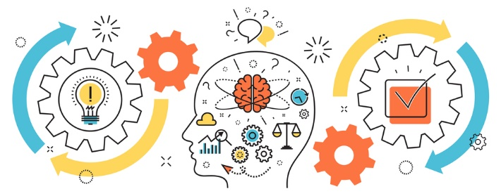 State of Kansas

Project Management

Class Offerings

**Unleashing the Potential of AI & Advanced Prompt Engineering in Project Management**

October 3-4, 2024 8:30am-4:30pm

$260 per participant* PDU’s – 13

This course is a two-day instructor-led course with an extra free one-day self-paced component given to attendees. This two-day instructor-led course will explore the breadth and depth of AI and its applications in project management The free one-day, self-paced ***Advanced Prompt Engineering and Writing Skills*** course helps participants use various forms of AI, such as ChatGpt, Gemini, and Claude, to begin, writing customized prompts to use AI to assist the project. Students will participate in breakout sessions and can ask questions as needed.

***Registration:*** Please register through our KITO website: [ebit.ks.gov/kito/training](https://ebit.ks.gov/kito/training)

Once there please select the class you wish to attend, complete the form online and email to [KITO@ks.gov](mailto:KITO@ks.gov). If you have any questions please contact Celena Ramirez at 785-368-7161, or [celena.m.ramirez@ks.gov](mailto:celena.m.ramirez@ks.gov).

***Cancelation Policy:***  Cancelations up to 20 business days prior to class date are eligible for a 100% refund. Less than 20 business days there is NO refund.

The Mathis Group, Inc. is a Project Management Institute (PMI) Registered Global Educational Provider.

*2% administrative fee included

PMI’s Talent Triangle Breakdown for this class: Technical=, Leadership=